QUEEN ELIZABETH BRIDGE

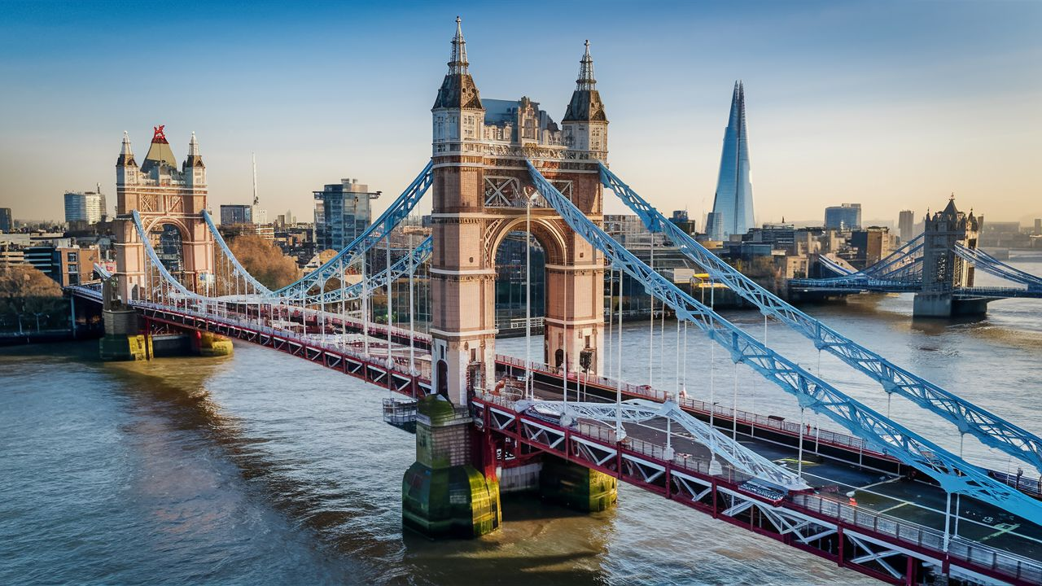

The Queen Elizabeth Bridge, also known as the QEII Bridge, is a remarkable piece of infrastructure located in the United Kingdom. Spanning the River Thames, it serves as a vital link between the counties of Essex and Kent, connecting the towns of Dartford and Thurrock. Named after Queen Elizabeth II, the bridge is a prominent feature of the Dartford Crossing, which comprises a tunnel and bridge complex facilitating the passage of vehicles across the Thames.

Constructed between 1988 and 1991, the Queen Elizabeth Bridge stands as an engineering marvel, boasting a length of around 812 meters (2,664 feet) and a main span of 450 meters (1,476 feet). This impressive structure accommodates four lanes of traffic, two in each direction, along with additional pedestrian and cycle paths. Its elegant design, featuring twin concrete towers supporting a suspended deck,
The construction of the Queen Elizabeth Bridge was necessitated by the increasing traffic congestion in the vicinity of the Dartford Tunnel, which was the primary crossing point prior to the bridge's completion. With the ever-growing demand for efficient transportation links between Essex and Kent, the bridge has played a crucial role in alleviating congestion and improving connectivity in the region.

